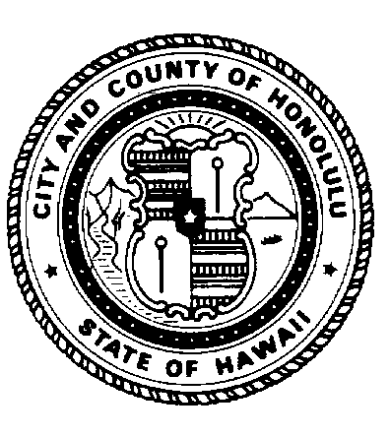 | CITY COUNCIL  CITY AND COUNTY OF HONOLULU  HONOLULU, HAWAII 96813-3077 | COMMITTEE ON PARKS AND  CULTURAL AFFAIRS
Voting Members:
Tom Berg, Chair
Ikaika Anderson, Vice Chair
Romy M. Cachola
Nestor Garcia
Breene Harimoto

AGENDA
REGULAR MEETING
COMMITTEE MEETING ROOM
TUESDAY, SEPTEMBER 27, 2011
10:30 A.M.

SPEAKER REGISTRATION:

Persons wishing to speak on items listed on the agenda are requested to register by 10:30 a.m. in the interest of time management as follows:

- use the On-Line City Council Speaker Registration form available at http://www1.honolulu.gov/council/attnspkpca.htm;
- send a fax to 768-3827 indicating your desire to register to speak, along with your name, phone number and subject matter;
- fill out the registration form in person; or
- call 768-3820.

Each speaker is limited to a one-minute presentation.

Persons who have not registered to speak should raise their hands at the time the item is announced and they will be given an opportunity to speak following oral testimonies of the registered speakers.

WRITTEN TESTIMONY:

If you wish to submit written testimony:

- fax to 768-3827 or
- go to http://www1.honolulu.gov/council/emailpca.htm to email your written testimony.

By submitting written testimony, you are not automatically registered to speak. Refer to “SPEAKER REGISTRATION” procedures above.

If submitted, written testimonies, including the testifier’s address, e-mail address, and phone number, may be posted by the City Clerk and available to the public on the City’s DocuShare Website.

Any physically challenged person requiring special assistance should call 768-3820 for details at least one day prior to the meeting date.
FOR APPROVAL

MINUTES OF THE AUGUST 30, 2011 MEETING

FOR ACCEPTANCE OF GIFTS / DONATIONS TO THE CITY

- RESOLUTION 11-261 – ACCEPTANCE OF GIFT FROM THE HAWAII GARDENIA CIRCLE. Relating to the acceptance of a gift to the City, valued at $10,887.72, from the Hawaii Gardenia Circle for the upkeep of the Ala Wai Golf Course 2nd Floor Multipurpose Facility. (Transmitted by Communication D-636)

FOR ACTION

- RESOLUTION 11-263 – PUBLIC SHOOTING COMPLEX IN KALAELOA. Resolution urging the City to develop a public shooting complex in Kalaeloa.

FOR DISCUSSION

- ONEULA BEACH PARK IMPACTS. Oneula Beach Park update including status on Master Plan: jersey barricades gifted to the City in non-compliance; adjacent properties to Oneula Beach Park to include drainage; and the status of native Hawaiian concerns pertinent to the development surrounding and of party to Oneula Beach Park.

- PALOLO DISTRICT PARK. Status on the repair of playground equipment at Palolo District Park.

Related communication:

D-639 Palolo Neighborhood Board No. 6, Resolution calling on the City to better maintain playground equipment at Palolo District Park.

TOM BERG, Chair
Committee on Parks and Cultural Affairs

